**Olist eCommerce Analysis**

*Data Analysis and Visualization using Power BI*



**Background**

The dataset for this study is from a Brazilian e-commerce company called Olist Store. It contains information on 100,000 orders made from 2016 to 2018 from various marketplaces in Brazil. The dataset includes details such as the status of the order, the price and payment information, customer location, and product attributes. It also includes customer reviews. The geolocation data associate Brazilian zip codes with latitude and longitude coordinates.

This is real commercial data, it has been anonymized, and references to the companies and partners in the review text have been replaced.

**Process**

There are a total of 9 CSV files that need to be imported to Power BI.

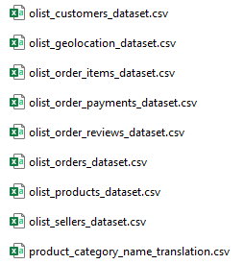

The dataset can be downloaded [here](https://drive.google.com/file/d/1Rrv8GKkEbntmYtAQ61JH66Kn3uE95mLM/view)

**Clean Data**

The first thing I did is to replace the translated product category with the main table because the original is in Spanish. Other tables don’t have header columns so I just promote header columns. I replaced all lowercase columns like the city, category name, and payment type with an upper case each letter.

Here’s the final model showing the relationships:

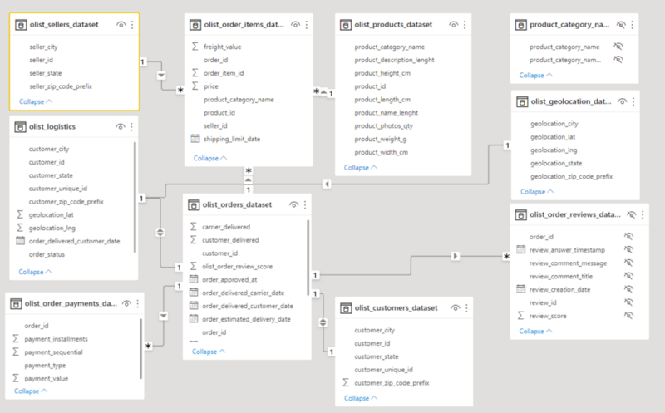

**Analyze**

**Sales Dashboard**

In the sales dashboard, I want to show the total sales, total freight value, total number of orders, and overall average product rating. All of these measures will be shown in cards.

I inserted a funnel to show the top 10 products category with the most sales.

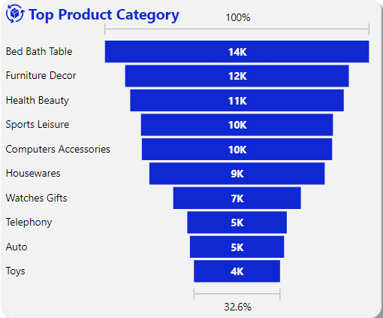

The *bed, bath, and table* category are in the Top 1 with 13,660 with an average review score of 3.98.

In a ribbon chart, I want to show the total sales and freight by date. You can drill down to see the chart by year, quarter, or month.

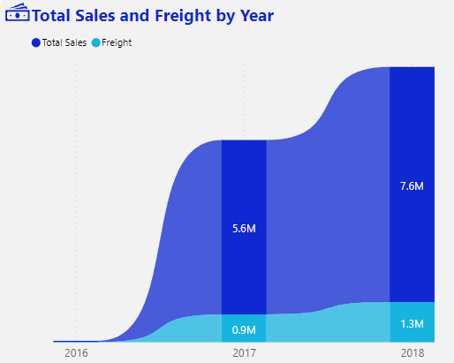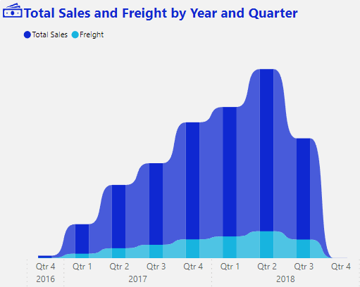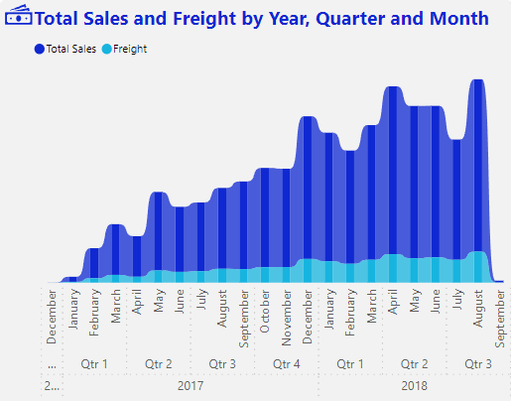

**Logistics Dashboard**

The measure that I need to get is the number of late deliveries. Here’s the DAX syntax:

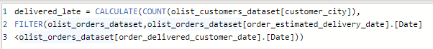

The next measure is to get how many orders were late dispatched by the seller:

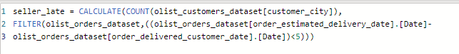

I added a new column to get the order processing time by subtracting order_approved_at from order_purchase_timestamp.

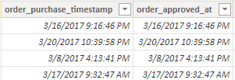

Another column to get the time of shipping to carrier and delivery time by subtracting *order_delivered_carrier_date* from *order_approved_at* and *order_delivered_customer_date* from *order_delivered_carrier_date* respectively.

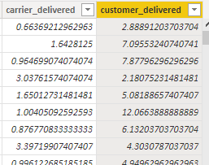

After getting the required measures and columns, I added cards that will show the number of late deliveries, late seller dispatch, average order processing time (in hours), average shipping to the carrier (in days), and average delivery time (in days).

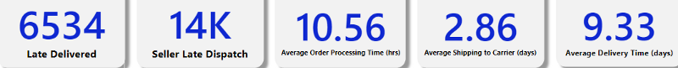

I also inserted a map chart to show the volume of orders in Brazil with legends by order status.

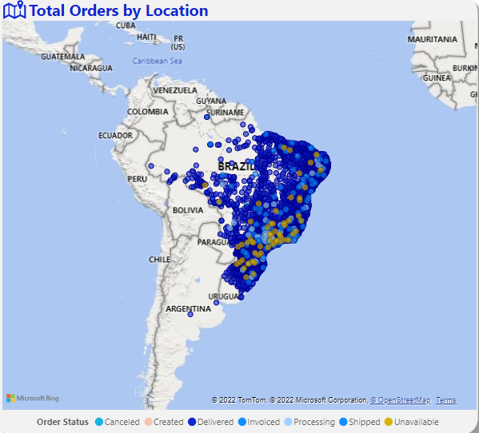

I created slicers to filter categories, states, order statuses, and dates by year, quarter, and month with a button to clear all filters.

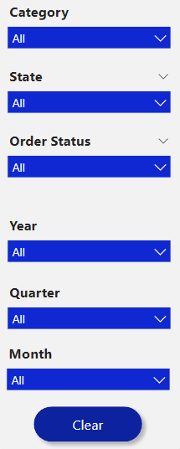

**Quality Dashboard**

For the product quality dashboard, I inserted cards to show the total reviews, the number of bad reviews, and the number of 5-star and 1-star reviews. In getting the number of bad reviews, I just set the filter to show 3 stars below reviews.



Next, I added a ribbon chart to show total orders and reviews by date.

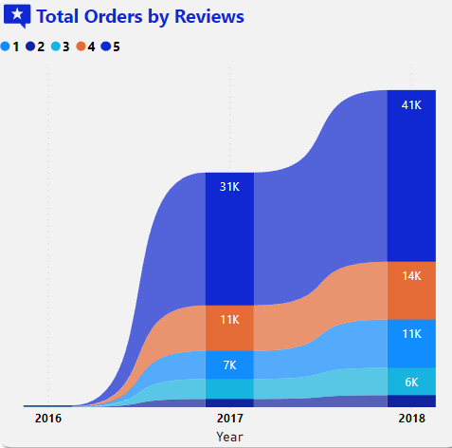Total orders and reviews by Year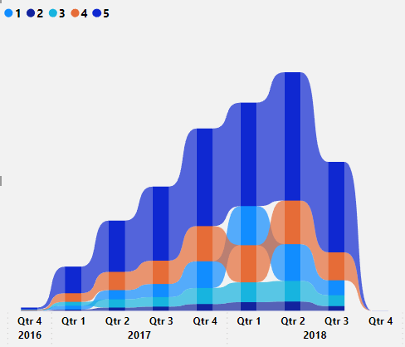Total orders and reviews by Year and Quarter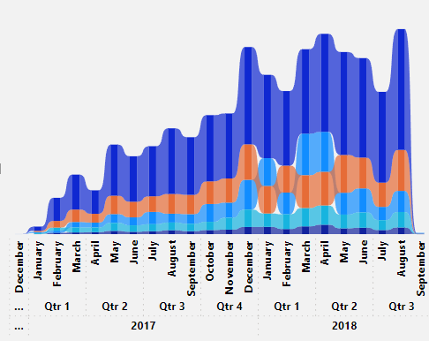Total orders and reviews by Year, Quarter, and Month

Next, I added a bar chart to show the top 5 highest-rated products.

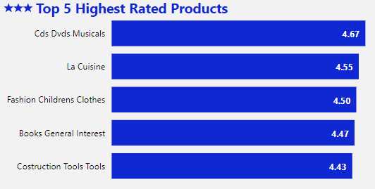

Also, the bottom 5 lowest-rated products.

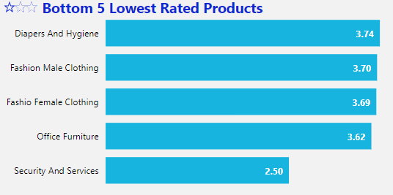

**Overview**

**Sales Dashboard**

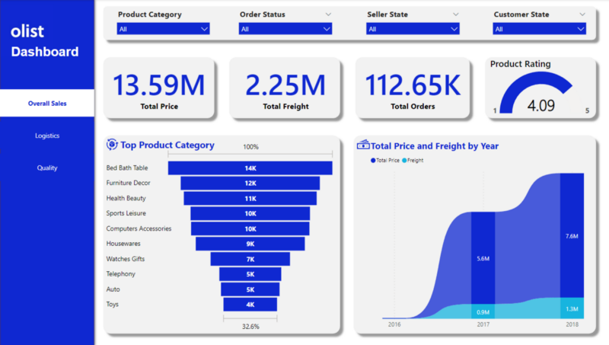

**Logistics Dashboard**

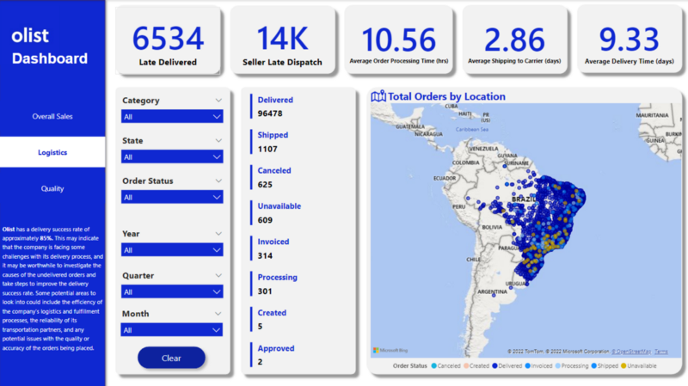

**Quality Dashboard**

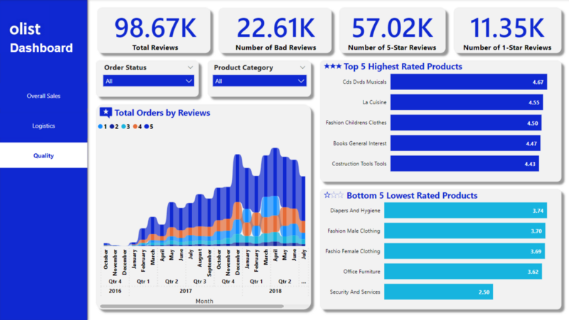

**INSIGHTS**

**Olist** has a delivery success rate of approximately **85%.** This may indicate that the company is facing some challenges with its delivery process, and it may be worthwhile to investigate the causes of the undelivered orders and take steps to improve the delivery success rate. Some potential areas to look into could include the efficiency of the company’s logistics and fulfillment processes, the reliability of its transportation partners, and any potential issues with the quality or accuracy of the orders being placed.

Olist company has a high level of customer satisfaction overall, with a significant number of positive reviews. However, the fact that the lowest-rated product category is “Security and Services” suggests that this type of product may need improvement.

**RECOMMENDATIONS**

1. Monitor and analyze customer reviews regularly to identify trends and areas for improvement. This could involve using data analysis tools to identify common themes in customer feedback and using this information to make changes and improve the customer experience.
2. Investigate the causes of undelivered orders. This could involve conducting an analysis of the undelivered orders to identify common themes or factors that may be contributing to the problem. For example, are certain regions or customer demographics more likely to have undelivered orders? Are there particular products or types of orders that are more likely to be undelivered?
3. Communicate with customers about the delivery process. Olist should be transparent with customers about the delivery process and provide them with regular updates on the status of their orders. This will help to build trust and create a positive customer experience. It will also give customers the opportunity to provide feedback on their experiences with the delivery process, which can be used to identify areas for improvement.
4. Overall, the key is to continue providing high-quality products and services, while also being responsive to customer feedback and working to improve areas that may need attention. Also regularly monitor and review the delivery success rate and communicate with customers about the process.

*Check out the repository here:* <https://github.com/neilangelomartinez/olist-ecommerce-analysis>